**Unit 4: Systems**

**Lesson 1: Solving Linear/Inequality systems graphically**

**Objectives:**

* **I can identify the solution of a system of two equations or inequalities.**
* **I can graph a system of two linear equations to find their intersection point.**
* **I can solve a real-life system of linear equations or inequalities graphically.**

**Agenda:**

* **Do Now: Linear Equations and inequalities Regent Questions**
* **Notes: Solving systems of two linear equations and inequalities graphically.**
* **Practice: Applied problems**

**Vocabulary:**

* **Systems; Boundary line, Constraints.**

**Focus Questions:**

1. **What is a system of equations or inequalities?**
2. **What does it mean to solve a system graphically?**

**Homework: Worksheet 4-1**

**Extra resources:**

<http://www.bing.com/videos/search?q=Solving+systems+graphically&&view=detail&mid=6D6BDAA0F5C5F2E8C7CE6D6BDAA0F5C5F2E8C7CE&FORM=VRDGAR>



**Linear Equations**

1. Write an equation of a line that passes through the points

(2, 4) and ( - 4, 3).

Slope first Then: Point-slope form

|  |
| --- |
| 1.2. 3.4. |

1. A health club charges $400 for a one-time joining fee and then $65 per month for membership.
2. Write an equation that shows the total amount of money (in dollars), d, that someone would spend on gym membership for t months.
3. How much would the person have spent after 1 month? 6 months?
4. What is the slope of this function? What does it mean in the context of this story?
5. What is the y-intercept of this function? What does it mean in the context of this story?

**Key points of today’s lesson: How do I solve a system of equations graphically???**



|  |  |  |  |  |  |  |  |  |  |  |  |  |  |  |  |  |  |  |  |  |  |  |
| --- | --- | --- | --- | --- | --- | --- | --- | --- | --- | --- | --- | --- | --- | --- | --- | --- | --- | --- | --- | --- | --- | --- |
|  | 1. Solve the system of linear equations graphicaly:   y=2x+2  y=x−1  **Use a table of values to show the solution:**    Image result for graphing grid   |  |  |  | | --- | --- | --- | | **x** | **Y (1)** | **Y (2)** | |  |  |  | |  |  |  | |  |  |  | |  |  |  | |  |  |  | |  |  |  |   **Solution:** |

**Solving Linear/Linear system of inequalities graphically:**



|  |  |
| --- | --- |
|  | 2. Solve the system of linear inequalies graphicaly: $$1) y>\frac{2}{3}x-2$$ $$2) y≥\frac{6}{-5}x-6$$   * Inequality # 1: Shaded above or below? Dotted or solid? * Inequality # 2: Shaded above or below? Dotted or solid?   Image result for graphing grid  **Label the half plane in a different color**  **Pick a solution that satisfies both inequalities.** |

**Solving systems in the context of real world:**



New Paltz Cinemas has two movie deals going on this year. The Movie Madness Deal offers movie tickets at $6 each plus an $18 membership fee. The Movies are Maddening Deal offers movie tickets at $2 each plus a $30 membership fee. At the current prices to see a movie, you want to take advantage of one of these deals.

Write an equation to represent each movies deal. 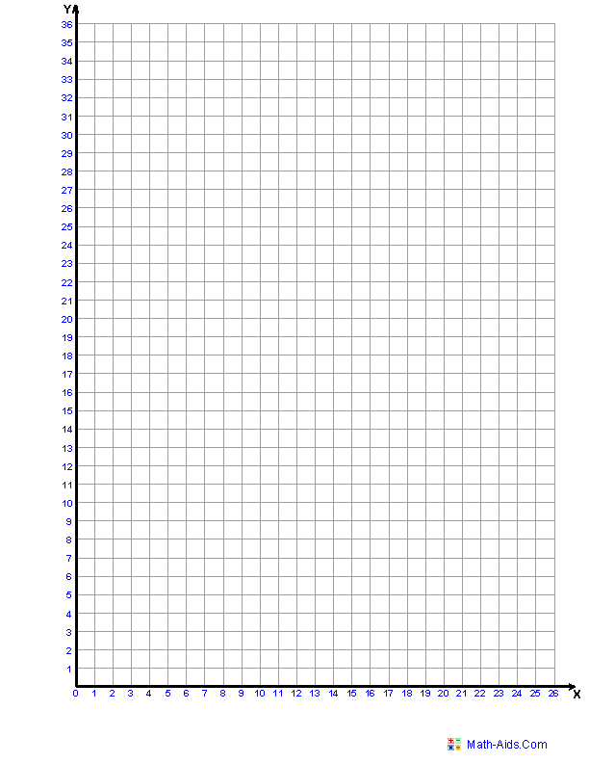

1. Movie Madness:
2. Movies are Maddening:
3. Graph these equations on the graph below. (Don’t forget to label the x and y axis and the equations.)
4. If you get the Movie Madness Deal, and your best friend gets the Movies are Maddening Deal, how many movies do you have to see for the price to be the same?
5. If you both see 8 movies this year, who paid less money? Explain your answer or show a table of values. Must answer in a complete sentence.



Mr. Hansen is buying donut and bagels for his colleagues and work. Each donut cost $1 and each Bagel cost $3. If he needs to buy at least 50 donuts and bagels and he wants to spend $ 60 at most.

1. Graph the system of linear inequalities that model these **constraints.**
2. Determine a combination of bagels and donuts that Mr. Hansen can buy to meet the constraints.



**Summary: Fill in the blanks:**

* By definition, a ______ of equations is simply two or more _________ in the same ________

**{System, equations, variable}**

* Solving a ______ means that you are finding the ordered pair(s) that will "work" in all of the ________ in the system.

**{System, equations}**

* There are _____ possible solutions to any system: ___ _____ , ____ , and __________ ____

**{three, one, none, infinitely many}**

* ________: The ________ of the system is revealed as the point of ____________ of the two lines.

**{Graphing, solution, intersection}**

* There are _____ ways to solve a system.

**{three, two, one}**



**Name: _________ Date: _____________**

**Systems algebraically: HW 4-1**

1. On the set of axes below, solve the following system of equations graphically. State the P.O.I

4x – 2y = 10

y = -2x -1

Must provide a table of values to justify the solution

1. On the set of axes below, solve the following system of inequalities graphically. Label the solution set.

Y $≤$ 4x-1

2x + y > 5

1. The Kurzy cable company has a monthly fee of $32.00 and an additional charge of $8.00 for each premium channel. The Russ Cable Company has a monthly fee of $26.00 and an additional charge of $10.00 for each premium channel. The Thompkins family is deciding which of these 2 companies to subscribe to.

0 1 2 3 4 5 6

~

20

25

30

35

40

45

50

55

60

65

70

75

Write an equation describing each cable company.

1. The Kurzie Cable Company:

1. The Russ Cable Company:

1. For what number of premium channels will the total monthly subscription fee for both companies be the same?
2. What is the cost at that time?

1. Graph and label and provide a table.

Have you worked on your regents’ review 2???